**COA Unit 1.**

Computer architecture is a framework for comprehending how computers work and how their components function to perform tasks. Computer architecture comprises hardware, software, and communication components.

The operation of a computer system depends on the central processing unit (CPU), memory, input/output devices, and storage devices, which is called computer architecture.

Computer Organization vs. Architecture

* Computer Organization refers to the operational structure and hardware components of the computer. It focuses on how a computer's different parts connect and interact to execute instructions.
* Computer Architecture deals with the abstract design and structure of the computer system. It is concerned with the functionality and behavior of a computer, defining the system's hardware components' design.

Components of Computer Architecture

Basic Components of a Computer System

* Input Devices: Devices like keyboards, mice, and scanners that send data to the computer.
* Output Devices: Devices like monitors and printers that present data to the user.
* Memory/Storage: Includes primary (RAM, Cache) and secondary (HDD, SSD) storage for data and programs.
* Central Processing Unit (CPU): The brain of the computer. It consists of:
  + Control Unit (CU): Manages and directs the flow of data between the CPU, memory, and I/O devices.
  + Arithmetic Logic Unit (ALU): Performs arithmetic and logical operations.
  + Registers: Small, fast storage areas within the CPU that hold data temporarily during processing.
* System Bus: A communication pathway for transferring data between different components like CPU, memory, and I/O devices.
* Power Supply Unit (PSU): Provides electrical power to the computer.

1. Memory and Storage
   * Primary Memory (Volatile):
     + Random Access Memory (RAM): Temporary storage used by the CPU to hold data and instructions during execution.
     + Cache Memory: Faster than RAM, stores frequently accessed data and instructions for quick access by the CPU.
   * Secondary Memory (Non-Volatile):
     + Hard Disk Drives (HDDs) and Solid State Drives (SSDs): Used for long-term storage of programs and data.
     + Optical and Magnetic Storage: CDs, DVDs, and magnetic tapes are other forms of secondary storage.
2. Central Processing Unit (CPU) Architecture
   * Instruction Set Architecture (ISA): The set of instructions that a CPU can execute. This defines the machine language the CPU understands.
   * Microarchitecture: The way the ISA is implemented in the CPU, detailing how data is processed internally.
   * Control Flow: Describes how instructions are fetched, decoded, and executed in the CPU.
     + Fetch: The CPU fetches an instruction from memory. o Decode: The CPU decodes the fetched instruction.
     + Execute: The decoded instruction is executed by the ALU or other components.
3. Input/Output (I/O) Organization
   * I/O Devices: Hardware used for interaction with external environments, like printers, scanners, keyboards, etc.
   * I/O Bus: A communication path between the CPU and peripheral devices.
   * I/O Controllers: Manage the communication between I/O devices and the system bus.
4. Bus and Data Transfer
   * System Bus: A set of parallel wires used for communication between the CPU, memory, and I/O devices.
     + Data Bus: Transfers data between components. o Address Bus: Transfers the address where data is stored.
     + Control Bus: Transfers control signals to coordinate operations between components.
5. Basic Performance Factors
   * Clock Speed: The speed at which a CPU executes instructions, measured in GHz.
   * CPI (Cycles Per Instruction): Number of clock cycles needed to execute an instruction.
   * Throughput: The amount of work a CPU can perform in a given time.
   * Latency: The time taken for an instruction or data transfer to complete.

1. Types of Processors
   * CISC (Complex Instruction Set Computer): Processors with a large set of instructions, capable of executing complex tasks in fewer lines of code.
   * RISC (Reduced Instruction Set Computer): Processors with a smaller set of instructions, requiring more instructions for complex tasks but can execute them faster.
   * Parallel Processors: Systems with multiple processors working simultaneously to increase processing power.

Von-Neumann computer architecture:

Von-Neumann computer architecture design was proposed in 1945.It was later known as Von-Neumann architecture. Historically there have been 2 types of Computers:

1. Fixed Program Computers – Their function is very specific and they couldn’t be reprogrammed, e.g. Calculators.
2. Stored Program Computers – These can be programmed to carry out many different tasks, applications are stored on them, hence the name.

Modern computers are based on a stored-program concept introduced by John Von Neumann. In this stored-program concept, programs and data are stored in the same memory. This novel idea meant that a computer built with this architecture would be much easier to reprogram.

The basic structure is like this,

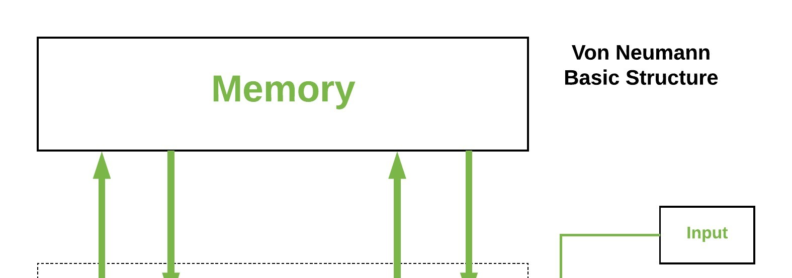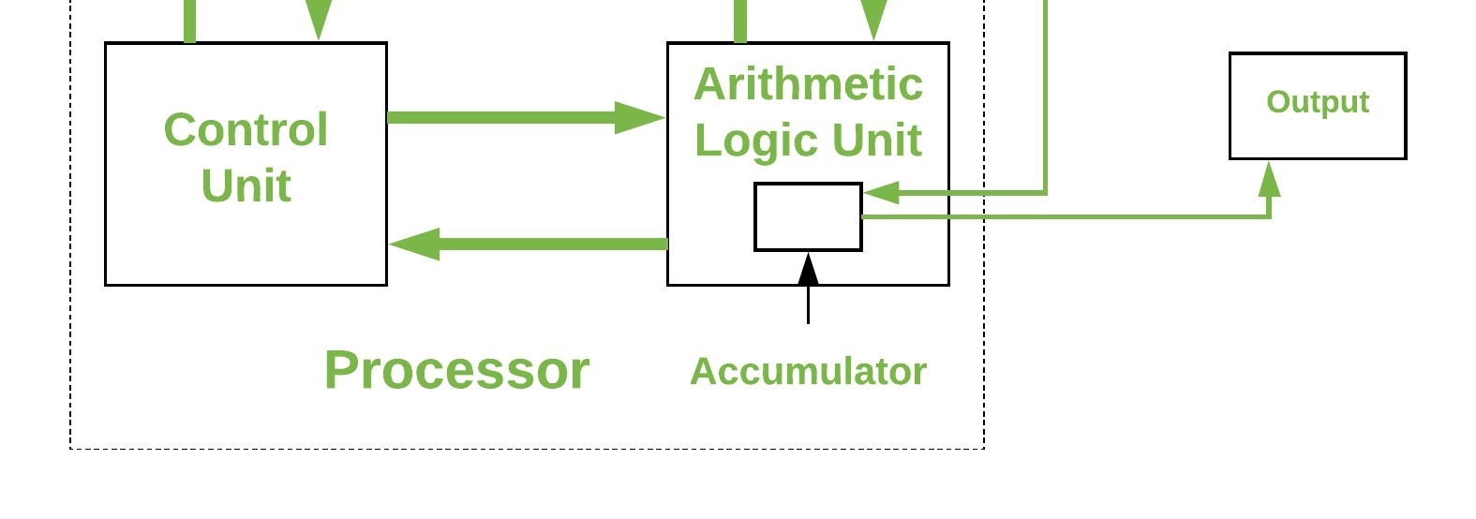

It is also known as ISA (Instruction set architecture) computer and is having three basic units:

1. The Central Processing Unit (CPU)
2. The Main Memory Unit
3. The Input/Output Device Let’s consider them in detail.
4. Central Processing Unit: The central processing unit is defined as the it is an electric circuit used for the executing the instruction of computer program.

It has following major components:

* 1. Control Unit(CU)
  2. Arithmetic and Logic Unit(ALU)

3. Variety of Registers

* Control Unit –

A control unit (CU) handles all processor control signals. It directs all input and output flow, fetches code for instructions, and controls how data moves around the system.

* Arithmetic and Logic Unit (ALU) –

The arithmetic logic unit is that part of the CPU that handles all the calculations the CPU may need, e.g. Addition, Subtraction,

Comparisons. It performs Logical Operations, Bit Shifting Operations, and Arithmetic operations.

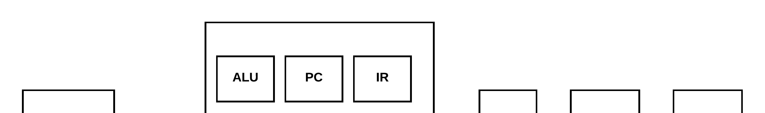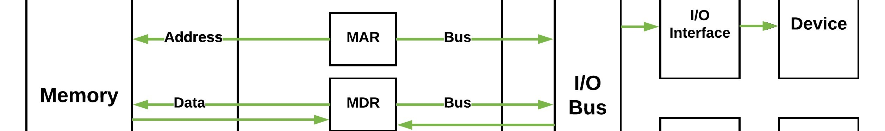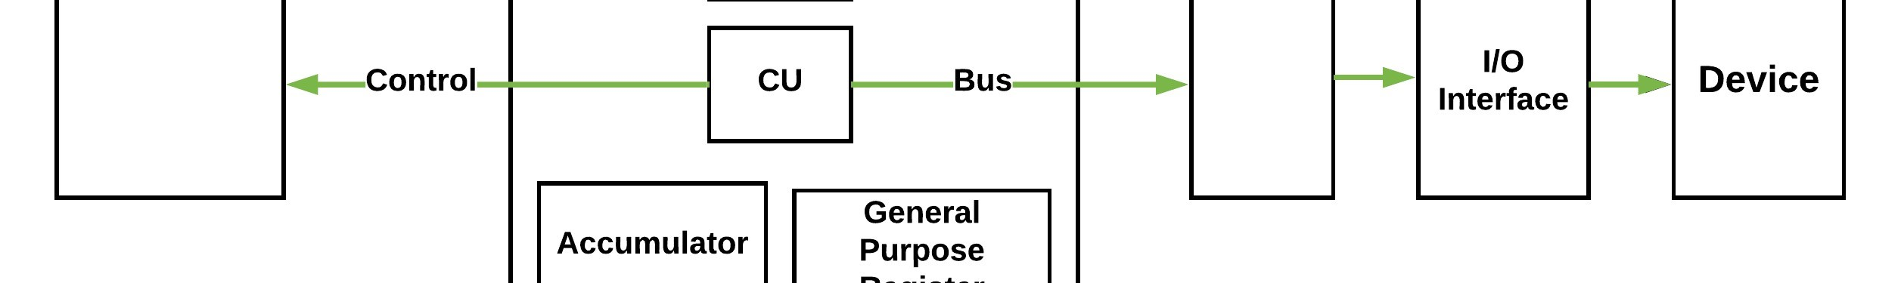

Figure – Basic CPU structure, illustrating ALU

* Registers – Registers refer to high-speed storage areas in the CPU. The data processed by the CPU are fetched from the registers. There are different types of registers used in architecture :-
  1. Accumulator: Stores the results of calculations made by ALU. It holds the intermediate of arithmetic and logical operatoins. it acts as a temporary storage location or device.
  2. Program Counter (PC): Keeps track of the memory location of the next instructions to be dealt with. The PC then passes this next address to the Memory Address Register (MAR).
  3. Memory Address Register (MAR): It stores the memory locations of instructions that need to be fetched from memory or stored in memory.
  4. Memory Data Register (MDR): It stores instructions fetched from memory or any data that is to be transferred to, and stored in, memory.
  5. Current Instruction Register (CIR): It stores the most recently fetched instructions while it is waiting to be coded and executed.
  6. Instruction Buffer Register (IBR): The instruction that is not to be executed immediately is placed in the instruction buffer register IBR.

* Buses – Data is transmitted from one part of a computer to another, connecting all major internal components to the CPU and memory, by the means of Buses. Types:
  1. Data Bus: It carries data among the memory unit, the I/O devices, and the processor.
  2. Address Bus: It carries the address of data (not the actual data) between memory and processor.
  3. Control Bus: It carries control commands from the CPU (and status signals from other devices) in order to control and coordinate all the activities within the computer.
* Input/Output Devices – Program or data is read into main memory from the input device or secondary storage under the control of CPU input instruction. Output devices are used to output information from a computer. If some results are evaluated by the computer and it is stored in the computer, then with the help of output devices, we can present them to the user.

Working of the Von Neumann Architecture

The Von Neumann cycle is also known as the Fetch-Decode-Execute Cycle. It describes the sequence of steps the CPU follows to execute instructions from memory:

* 1. Fetch: The control unit fetches the next instruction from memory (based on the program counter, which points to the address of the next instruction).
  2. Decode: The fetched instruction is decoded by the control unit to determine the operation to be performed.
  3. Execute: The CPU executes the instruction. This could involve arithmetic/logic operations (handled by the ALU) or data transfer (moving data from memory to CPU or vice versa).
  4. Store: The result of the execution is stored back in memory or in the CPU registers.

Characteristics of Von Neumann Architecture 1. Shared Memory for Data and Instructions o Both instructions (code) and data are stored in the same memory, which simplifies hardware design.

* + - This leads to a potential bottleneck known as the Von Neumann Bottleneck, where the CPU has to wait for data or instructions due to the limited bandwidth of the shared memory bus.
  1. Sequential Execution o Instructions are processed one after another in a linear sequence (fetch-decode-execute cycle). This means that there is no parallelism or simultaneous execution of instructions by default.
  2. Program Counter o The Program Counter (PC) is a special register in the CPU that keeps track of the address of the next instruction to be executed. After each instruction is executed, the PC is updated to point to the next instruction.
  3. Uniform Memory Access o Since both instructions and data reside in the same memory space, there is no distinction between fetching data or fetching instructions in terms of memory access. The CPU accesses both in the same way.

Advantages of Von Neumann Architecture

* Simplicity: It simplifies the design and development of computers, as there is only one memory space for both instructions and data.
* Flexibility: It allows the stored program concept, where programs can be stored in memory and easily modified or executed.
* Cost-Effective: Fewer components are needed since there is no need to separate instruction and data memories.

Disadvantages of Von Neumann Architecture

* 1. Von Neumann Bottleneck:
     + The CPU can only access one piece of data or one instruction at a time because both are stored in the same memory, leading to a bottleneck when transferring data to and from memory. o This limits the overall processing speed, as the CPU often has to wait for data to be fetched from memory.
  2. Sequential Processing:
     + Without advanced techniques like pipelining or parallelism, the system processes instructions sequentially, which can limit performance.
  3. Inflexibility for High-Performance Systems:
     + High-performance computers, such as those used for scientific computation or real-time processing, can be limited by the Von Neumann architecture due to its inability to handle simultaneous instruction and data transfers.

How many generations of the computer?

A computer is an electronic machine that operates information; it accepts raw data as an input and provides a meaningful result after processing. It can be used to edit or create spreadsheets, presentations, type documents, browse the Web, play games, send an email, and more.

The generation of computers is based on when major technological changes occur within the computer, like the employment of the microprocessor, vacuum tubes, and transistors. The primary generation of this complex system began about 1940, and there are five generations of the computer till 2020.

# First-generation (1940 - 1956)

The first electronic computer used vacuum tubes as a serious piece of technology that was ENIAC, which stands for Electronic Numeric Integrated And Calculator, invented by J.W.Mauchy and J.P.Eckert. From 1940 through 1956, vacuum tubes were widely employed in computers. The first-generation computers were very large in size and took up much space in the room because vacuum tubes were larger components used in the computers. Even some of the first-generation computers were such large in size; they took up an entire room. It weighed more than 30 tons and included 70,000 resistors, 10,000 capacitors, additionally as approximately 20,000 vacuum tubes. The below picture is of the vacuum tubes. Some samples of the primary generation of computers are given below:

o UNIVAC o IBM-701 o ENIAC o EDVAC o IBM-650

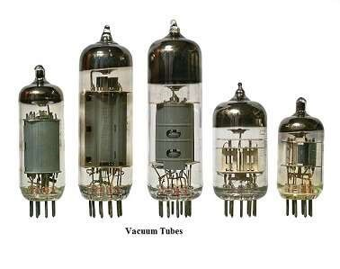

# Advantages of the first-generation computer

1. These computers were in no time in terms of calculating. They might calculate in milliseconds.
2. Vacuum tubes are the electronic components available at that time, which were used by these computers.

# Disadvantages of the first-generation computer

1. These computers' weight was about 30 tones and took up a lot of space as they were very big in size.
2. These computers were very costly and based on vacuum tubes.
3. Due to the presence of magnetic drums, they were only able to store a small amount of information.
4. As the first generation of computers were used vacuum tubes, which need a large cooling system.
5. They consumed a large amount of energy and had less work efficiency.
6. They needed punch cards to give input and had limited programming capabilities.

# Second generation (1956 - 1963)

Instead of vacuum tubes, the second generation of computers was supported transistors. From 1956 through 1963, transistors were widely utilized within the second generation of computers. As compared to the primary generation of computers, these computers were small in size because they used transistors in these generations of computers that were smaller than vacuum tubes. Also, in terms of speed, the second generation of computers was faster. And they were cheaper to create. In 1956,

computer TX-0 was introduced, which was the primary computer that used transistors. Some samples of the second generation of computers are given below:

o CDC 3600 o Honeywell 400 o UNIVAC 1108

o

IBM 7094

o

CDC 1604, and many more

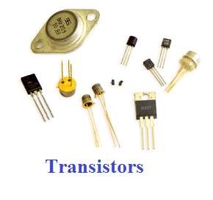

## Advantages of the second generation of computers

1. The dimensions of the electron component decreased thanks to the existence of transistors rather than vacuum tubes. Hence, the scale of those computers was small in size as compared to the previous generation of computers.
2. These computers consumed less energy and did not produce the maximum amount of heat because of the first generation of computers.
3. In these computers, punch cards and Assembly language were used to give input.
4. As compared to the first generation, it had better portability and low cost.
5. Furthermore, these computers were faster in speed as could calculate data in microseconds.

## Disadvantages of the second generation of computers

1. It required a cooling system and constant maintenance.
2. Also, these computers were used only for a particular objective.

## Third generation (1964 - 1971)

The third generation of computers was supported Integrated circuits. In 1958-1959, Jack Kilby and Robert Noyce invented the IC (Integrated circuit), which was a signal component that could have a number of transistors. The utilization of Integrated circuits within the computers made them faster and helped reduce the scale of computers as compared to second-generation computers.

In the mid to late 1960s, almost all computers have used Integrated circuits. Although many people considered the time period of the third-generation computer is from 1964 to 1971. Today's computers are still using Integrated circuits. Below, some examples of the third generation of computers are given:

o IBM 370 o PDP-8 o ICL 2900

o

IBM 360

o

PDP-11, and many more

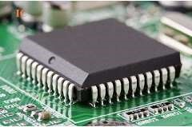

## Advantages of the third generation of computers

1. As compared to the second-generation computer, these computers were cheaper in cost.
2. This generation's computers used Integrated circuits that made them small in size. Also, they were reliable and faster in speed.
3. The use of an Integrated circuit was not only beneficial for reducing the size of the computer; it also enhances the performance of the computer comparing the secondgeneration computer.
4. The third generation of computers introduced a big storage capacity.
5. In these computers, keyboard and mouse were used to give the input rather than punch cards.
6. These generation computers were much fast in terms of calculation; they decrease the computational time from microseconds to nanoseconds.
7. Furthermore, for better performance, these computers used operating systems and used multiple programming and the concept of time-sharing.

## Disadvantages of the third generation of computers

1. Air conditioning was required by these computers.
2. The manufacturing of IC chips required a highly sophisticated technology; also, IC chips are not easy to maintain.

## Fourth generation (1972 - 2010)

The Microprocessor, commonly called a CPU (Central Processing Unit), was used by the fourth generation of computers. A microprocessor is used in a computer that led to makes a computer more powerful and small in size as well as fits easily on a desk. Also, microprocessors, along with integrated circuits, helped to introduce the laptop. For providing users more comfort, GUI (Graphics User Interface) technology was exploited. The IBM 5100, Altair 8800, Micral, and some others are older computers that used a microprocessor. Although the fourth generation is considered to have ended in 2010, in modern times, the microprocessor is still in use in computers. The below is of the microprocessor. Some examples of the fourth-generation computers are given below:

o STAR 1000 o PUP 11

o

IBM 4341

o

DEC 10

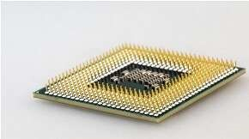

## Advantages of the fourth generation of computers

1. The first advantage of this generation computer is that the size gets reduced and fastest in computation, comparing to the previous generation of computer.
2. Its heat generated is negligible and required less maintenance.
3. In these types of computers, all kinds of high-level language can be used.

## Disadvantages of the fourth generation of computers

1. The fabrication and design of the microprocessor are not simple.
2. In many cases, air conditioning is needed due to the occurrence of Integrated circuits.
3. For making the Integrated circuit, advanced technology is required.

## Fifth-generation (2010 to present)

The fifth generation of computers is predicated on artificial intelligence. AI is an advanced technology that contains various possible applications all over the world. The primary purpose of this generation of computers is to make a device more capable of self-organization and learning, including could respond to natural language input. The ten million electronic components have consisted of the production of a microprocessor as this generation is based on Ultra Large-Scale Integration (ULSI). Although AI made computers more powerful, there is still a need for some improvement in the computer.

IBM's Watson is a common example of computers used AI, which was featured as a contestant on the TV show Jeopardy.Microsoft's Cortana on Windows 8 and Windows 10 computers and. Apple's Siri on the iPhone are some other examples of computers that used AI. Furthermore, AI is also used in a search engine like Google to process user searches. Some more examples are:

o UltraBook o Chromebook o Desktop

o

Laptop

o

NoteBook

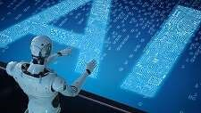

## Advantages of the fifth generation of computers

1. It has unique features and is available in several sizes.
2. It is more reliable and has the ability to work much faster.
3. It offers computers that have a more friendly UI (User Interface), including multimedia features.

## Disadvantages of the fifth generation of computers

1. In these computers, very low-level languages are required.
2. They may be harmful in terms of making human brains doomed and dull.

### Computer Classification

A computer is a device that transforms unusable data into information. According to the set of instructions the user gives it, it processes the input and generates the desired outcome. Modern digital computers are classified on the basis of their size and capacity. The size and data handling capabilities of the various types of computers may be used to categorize them into two groups.

1. Computers according to Size:
   * Supercomputer.
   * Mainframe computer.
   * Personal computer.
   * Workstation.
   * Minicomputer.

1. Computers according to their Capacity to manage data:
   * Digital computer.
   * Hybrid computer.
   * Analog computer.

### Computer Classification

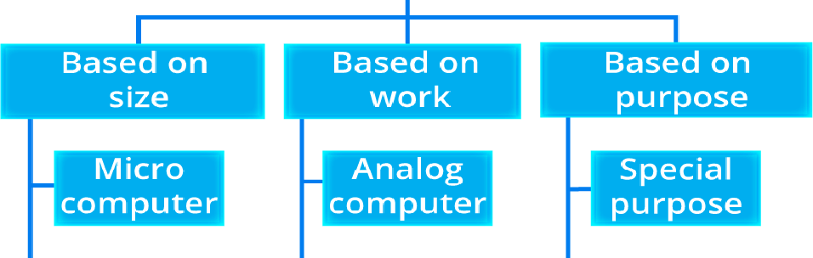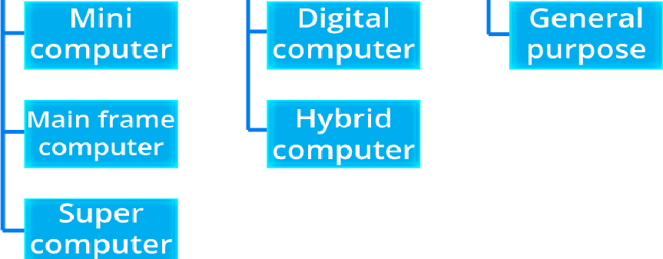

Classification of Computers

Classification of Computers

Different classifications of Computers are as follows.

### Classification According to Size

There are four different sorts of computers based on their size and how they are configured to operate:

1. Supercomputers

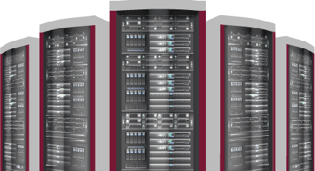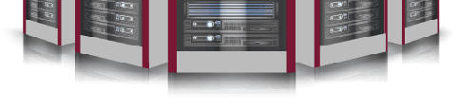

Supercomputer

The most efficient computers in terms of processing data and performance are supercomputers. These computers are used for research and exploratory purposes. Supercomputers are exceedingly large and highly expensive. It can only fit in large, air-conditioned spaces.

Supercomputers are used for a range of tasks, such as space exploration, seismic research, and the testing of nuclear weapons.

Supercomputer Features:

* + They make use of AI (Artificial intelligence)
  + They are the fastest and strongest;

They are very costly.

They are enormous in size.

They are employed by companies that manufacture goods.

They process information at a rapid rate.

1. Mainframe Computers

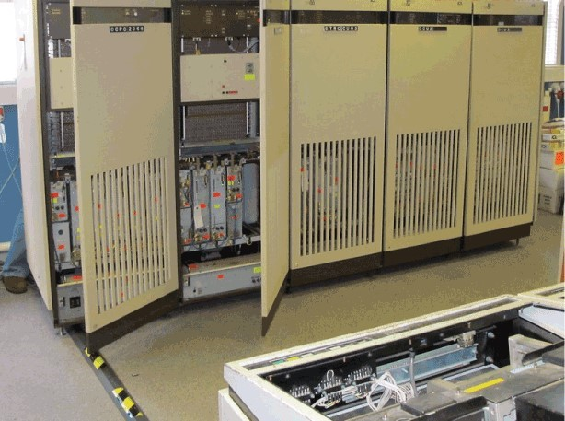

Mainframe Computers

Despite being less efficient than supercomputers, mainframe computers are nevertheless extremely expensive. Large corporations and governmental organizations frequently employ mainframe computers to run everyday operations. They have the ability to store and analyze a lot of data. To maintain information on their customers, students, and insurance policyholders, banks, colleges, and insurance companies utilize them. They may also act as a server in a network environment. Hundreds of users may be managed simultaneously by them.

Mainframe Computer Features:

They have enormous amounts of memory.

They are capable of running several different operating systems.

They have a significant number of CPUs with powerful processing speeds.

Tightly Coupled Clustering Technology is employed.

1. Minicomputers

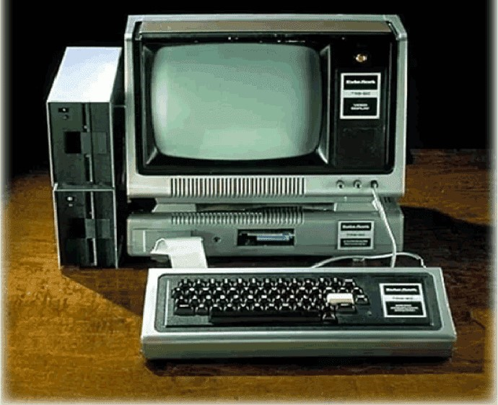

Mini Computer

Minicomputers are used by small businesses and industries. They go by the term "Midrange Computers." These minicomputers frequently have several users, just as mainframe computers. They are a bit slower than mainframe computers.

For example, the manufacturing department may employ minicomputers to keep an eye on specific production processes.

Features of Minicomputers:

• It is smaller than mainframes or supercomputers in terms of size.

In comparison to a mainframe or supercomputer, it is less costly.

It is able to perform many jobs at once.

It may be utilized by several users simultaneously.

It is utilized by small businesses.

1. Microcomputers.

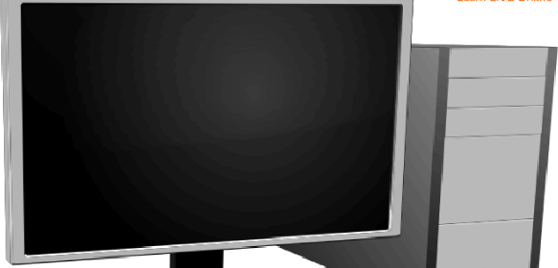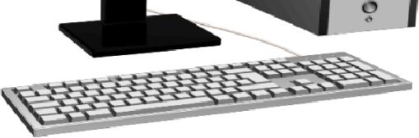

Micro Computer

A microcomputer, sometimes referred to as a personal computer (PC), is a type of computer that runs on a smaller scale than traditional computers (Personal Computer). A component that is commonly referred to as a motherboard houses the central processing unit (CPU), a microprocessor, memory in the form of ROM (Read Only Memory), RAM (Random Access Memory), I/O ports, and a bus system of connecting wires. They are the most affordable.

Features of Microcomputers:

* They are extensively employed for personal usage.
* They are smaller and comparably less expensive.
* Multi-user functionality is not supported.
* It has a limited computational capacity.
* They are quite simple to use.

### Based on Capacity

According to fundamental operating principles, there are three different kinds of computers. They are as follows: 1. Analogous Computers

Analog computers process analog data. Temperature, pressure, weight, depth, and voltage are a few examples of this type of data. These have an infinite range of values and are continuous quantities.

The first computers were analog, and they laid the groundwork for today's digital computers.

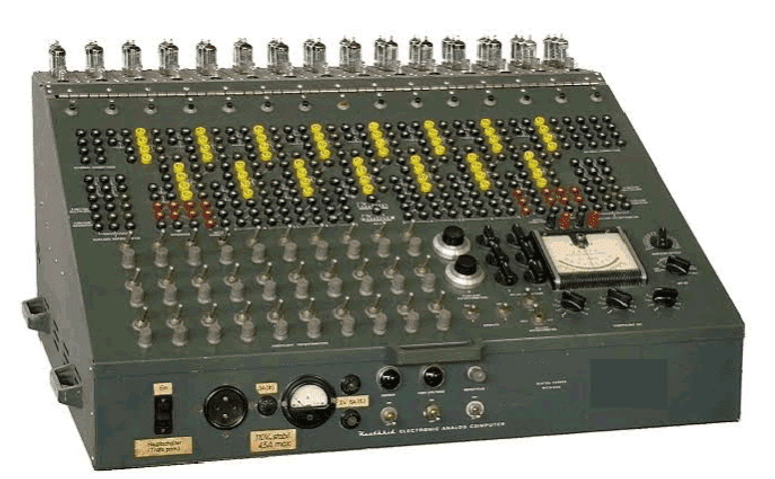

Analogous Computers

1. Digital Computers

In digital computers, letters, numbers, and other special symbols are represented by digits. On-off (ON-OFF) inputs are used by digital computers, and ON-OFF signals are also generated by them.

An ON is often represented by a 1 and an OFF by a 0, respectively. A digital computer is capable of processing both numerical and non-numerical data. In addition to doing fundamental arithmetic operations like addition, subtraction, multiplication, and division, it can also perform logical operations.



Digital Computer

1. Hybrid Computers

Computers that combine digital and analog components are called hybrid computers. It combines the best features of both types, having the speed of an analog computer with the memory and precision of a digital computer. Hybrid computers are typically used in specific applications where both forms of data need to be processed. As an example, a gas pump contains a processor that converts measurements of fuel flow into information about quality and cost.

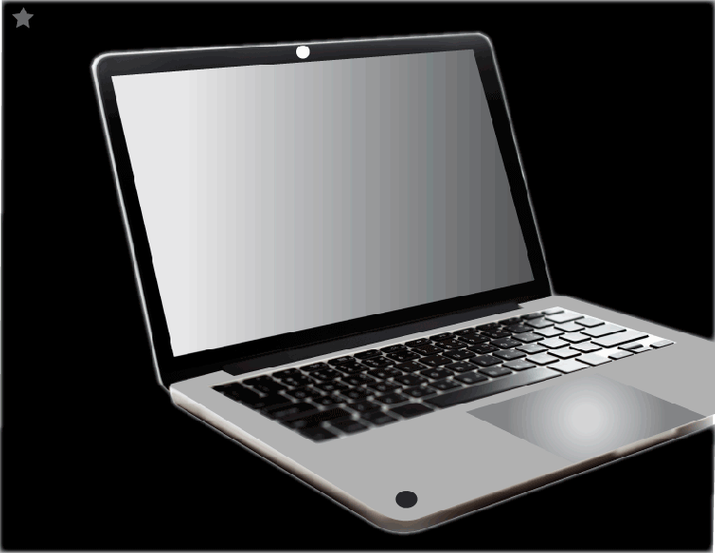

2. What are the uses of Super Computers?

Ans: Supercomputers are employed in data-intensive and computation-intensive scientific and technical operations including quantum mechanics, meteorology, fossil fuel extraction, molecular dynamics, physical modeling, aerodynamics, nuclear fusion research, etc.

In computer organization and architecture, arithmetic operations are crucial for performing various mathematical calculations within a computer system. These operations are carried out by the Arithmetic Logic Unit (ALU), which is a core component of the Central Processing Unit (CPU). Let's dive into each of the fundamental arithmetic operations with examples:

1. Addition

Binary addition works similarly to decimal addition but is carried out using only two digits: 0 and 1. The rules for binary addition are:

* + 0 + 0 = 0
  + 0 + 1 = 1
  + 1 + 0 = 1
  + 1 + 1 = 10 (which is 0 with a carry of 1)

Example:

Let’s add two binary numbers: 1011 (11 in decimal) and 1101 (13 in decimal).

1011

+ 1101

--------

11000

So, 1011 + 1101 = 11000 (which is 24 in decimal).

1. Subtraction

In binary subtraction, we use a concept called two’s complement to handle subtraction. This is because computers generally perform subtraction as an addition of the negative value.

* + Two’s complement: To subtract B from A (i.e., A - B), first find the two’s complement of B and then add it to A.

Example:

Let’s subtract 0110 (6 in decimal) from 1001 (9 in decimal).

1. First, find the two’s complement of 0110:

* + - Invert the digits: 1001
    - Add 1: 1001 + 1 = 1010 (This is the two’s complement of 0110)

2. Now, add the two’s complement of 0110 to 1001:

1001

+ 1010

--------

10011

Discard the carry, so the result is 0011 (3 in decimal). Therefore, 1001 - 0110 = 0011.

1. Multiplication

Binary multiplication is simpler than decimal multiplication because it involves only multiplying by 0 or 1. It works by shifting and adding.

Example:

Let’s multiply 1010 (10 in decimal) by 110 (6 in decimal).

1010 (10)

× 110 (6)

--------

0000 (this is 1010 × 0)

+ 1010 (this is 1010 × 1, shifted one position)

+ 1010 (this is 1010 × 1, shifted two positions)

--------

111100 (60 in decimal)

So, 1010 × 110 = 111100 (60 in decimal).

4. Division

Binary division works like long division in decimal, but with simpler calculations because the only possible quotients are 0 and 1.

Example:

Let’s divide 1110 (14 in decimal) by 10 (2 in decimal).

1. Start with the leftmost bit of the dividend 1110 (14). Compare it to the divisor 10 (2).
2. Perform the steps of binary division:
   * First, divide the first two bits 11 by 10, which gives a quotient of 1 and a remainder of 1.
   * Bring down the next bit 1, making the new number 11. o Divide again: 11 ÷ 10 = 1 with a remainder of 1.
   * Bring down the last bit 0, making 10. o Finally, 10 ÷ 10 = 1 with a remainder of 0.

So, 1110 ÷ 10 = 111 (which is 7 in decimal).

What are Binary Codes?

Binary codes are used to represent text, numbers, images, or other types of information in the form of 0 and 1, i.e., binary digits. Binary codes form the primary language of a digital computing system like a computer.

All digital system can understand and manipulate information expressed in binary language only. In the case of binary codes, each digit is called a binary digit or bit.

Binary codes represents information using 0 and 1. In a digital system, the binary codes are organized into segments like bits or bytes. A bit is either a binary 0 or 1. When 8 bits are grouped together, then it is called a byte. Each byte represents a piece of information in a digital system.

Binary Number System:

Computers use the binary number system, which consists of only two digits: 0 and 1. These digits are known as bits (binary digits). Unlike humans who use the decimal system (base 10), computers process information in base 2.

2. Representation of Data:

All forms of data—whether numbers, characters, or instructions—are ultimately represented in binary form within a computer. For example:

* Numbers: The number 9 in binary is represented as 1001.
* Characters: Using ASCII, the character A is represented as 65 in decimal, which converts to 1000001 in binary.

## Types of Binary Codes

Binary codes can be classified into the following major types −

* Weighted Binary Codes
* Non-weighted Binary Codes
* Alphanumeric Code
* Binary Coded Decimal (BCD)
* Error Detecting Code
* Error Correction Code

## Advantages of Binary Codes

Binary codes have several advantages in the field of digital electronics. Here are the key benefits of using binary codes −

* Simplicity − Binary codes use only two digits, i.e., 0 and 1 to represent information. It simplifies the electronic circuit design and implementation.
* Ease in Implementation − Binary codes use only two states namely, on and off. So, their implementation is straightforward.
* Ease of Storage − Binary codes are easy to store in digital memory devices like hard disk, CD, DVD, pen drive, etc. They require compact storage at higher efficiency.
* Easy and Fast Processing − Binary codes can be efficiently processed using digital systems having an arithmetic and logic unit. They allow fast and error-free computing.
* Easy Communication − Binary codes provide an efficient method of information transmission at a very high speed. Various error detecting and correcting techniques can be applied to binary codes that make the digital communication more efficient.
* Easy Scalability − Binary codes provide easy scalability of a digital system. We can increase the range of a digital system just by adding more bits in the code.
* Compatibility − Binary codes are compatible with a wide range of digital devices and systems.
* Reliability − Binary codes are highly immune to noise and interference that provide improved reliability in the digital system.

## Disadvantages of Binary Codes

Binary codes have several advantages as given above. However, they also have some disadvantages and limitations.

Some key disadvantages of binary codes are listed below −

* Binary codes are not human friendly. For human beings, reading and interpreting binary codes can be a complex task.
* In some situations, binary codes have to be converted into other number systems that adds extra computational overhead to the system.
* Binary codes require higher transmission bandwidth in communication channel.
* In binary codes, it is quite difficult to identify the errors. It becomes more challenging in case of long binary sequences.

## Applications of Binary Codes

Binary codes are widely used in various fields of digital electronics due to their high efficiency in information representation.

Listed below are some of the key applications of binary codes −

* Digital Computers − Binary codes are primarily used in digital computer to represent information and instructions.
* Digital Communication − Binary codes are also used for transmission of data and information using digital channels.
* Digital Displays − Binary codes are also used to display numbers and alphabets in digital systems.
* Barcode Systems − Binary codes are also used in barcode systems for product identification and inventory management. In this system, bars of different width and spaces between them represent binary digits that can be interpreted by a scanner.
* Data Storage − Binary codes are used to store information in digital devices like computer memory.
* Digital Control Systems − Binary codes are used to program a digital control system. In a digital control system, binary codes are used to represent different types of control signals and instructions used for automation.
* Computer Graphics − Binary codes are also used in computer graphics to represent colors, shapes, pixel values, and other information.

Boolean Algebra is a branch of mathematics that deals with binary variables and logic operations. In computer organization and architecture, Boolean algebra is crucial in the design and functioning of digital circuits, which form the basis of modern computing hardware like processors, memory, and control units.

Key Concepts in Boolean Algebra

1. Binary Variables:
   * Boolean algebra operates with binary variables, which can have only two values: 0 (false) and 1 (true).
2. Basic Boolean Operations: The three fundamental operations in Boolean algebra are:
   * AND (Conjunction): Output is true (1) only if both inputs are true (1). Denoted by · or &.
     1. · B = 1 if A = 1 and B = 1, otherwise 0.
   * OR (Disjunction): Output is true (1) if at least one input is true. Denoted by +.
     1. + B = 1 if A = 1 or B = 1 (or both), otherwise 0.
   * NOT (Negation): Output is the complement or inverse of the input. Denoted by A' or ¬A.

A' = 1 if A = 0, and A' = 0 if A = 1.

Truth Tables

Truth tables show all possible input values and their corresponding output for a Boolean function.

A B A·B (AND) A+B (OR) A' (NOT)

0 0 0 0 1

1. 1 0 1 1
2. 0 0 1 0

1 1 1 1 0

Boolean Algebra Theorems

Boolean theorems help simplify logic circuits, enabling efficient design and optimization of hardware components.

1. Identity Laws
   * A + 0 = A (OR identity)
   * A · 1 = A (AND identity)

These indicate that adding 0 to any variable has no effect, and multiplying by 1 has no effect.

1. Null Laws
   * A + 1 = 1 (OR null)
   * A · 0 = 0 (AND null)

Adding 1 to any variable always results in 1, while multiplying by 0 always results in 0.

1. Idempotent Laws
   * A + A = A
   * A · A = A

Performing an OR or AND operation between a variable and itself leaves the variable unchanged.

1. Complement Laws
   * A + A' = 1
   * A · A' = 0

A variable OR’ed with its complement is always 1, and AND’ed with its complement is always 0.

1. Double Negation Law
   * (A')' = A

Taking the NOT (negation) of a negated variable returns the original value.

1. Commutative Laws
   * A + B = B + A
   * A · B = B · A

The order of variables in an OR or AND operation does not matter.

1. Associative Laws
   * (A + B) + C = A + (B + C)
   * (A · B) · C = A · (B · C)

Grouping of variables in an OR or AND operation does not change the result.

1. Distributive Laws
   * A · (B + C) = (A · B) + (A · C) (AND distributes over OR)
   * A + (B · C) = (A + B) · (A + C) (OR distributes over AND)
2. Absorption Laws
   * A + (A · B) = A
   * A · (A + B) = A

A variable absorbs its conjunction or disjunction with another variable.

What is a Logic Gate?

A logic gate is a fundamental building block of digital circuits. In digital electronics, there are seven main types of logic gates used to perform various logical operations. A logic gate is basically an electronic circuit designed by using components like diodes, transistors, resistors, capacitors, etc., and capable of performing logical operations. It is an electronic device that performs a basic logical operation on one or more binary inputs to produce a single binary output. In digital electronics, binary inputs and outputs are represented as either 1 (True, High) or 0 (False, Low). Logic gates are essential in designing digital systems such as computers, calculators, and other devices.

Use of Logic Gates

Logic gates are used in:

* Computation: Performing arithmetic operations and comparisons in processors and controllers.
* Decision-making circuits: Used to control the flow of data, based on certain conditions (such as allowing access, triggering actions).
* Memory and Storage: Logic gates are used in flip-flops and memory cells to store and manipulate data.
* Signal Processing: Handling and interpreting signals in embedded systems and communication devices.

Types of Logic Gates and Examples

1. AND Gate

o An AND gate produces an output of 1 only if all its inputs are 1. If any input is 0, the output is 0. o Truth Table:

Input A Input B Output (A AND B)

0 0 0

* + 1. 1 0 1 0 0
    2. 1 1

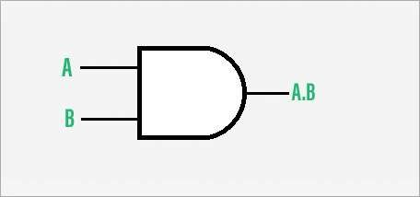

o Example: In an elevator system, if two buttons are pressed (both inputs are 1), the elevator moves. If either button is not pressed, it remains idle.

1. OR Gate

o An OR gate produces an output of 1 if at least one of its inputs is 1. If all inputs are 0, the output is 0. o Truth Table:

Input A Input B Output (A OR B)

* + 1. 0 0 0 1 1
    2. 0 1

1 1 1

o

* + - * 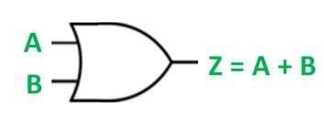

o

* + - * Example: A room with two switches controlling a single light. If either switch is turned on, the light will turn on.

1. NOT Gate (Inverter) o A NOT gate has a single input and produces an output that is the opposite

(complement) of the input. If the input is 1, the output is 0, and vice versa. o Truth Table:

Input A Output (NOT A)

* + 1. 1
    2. 0

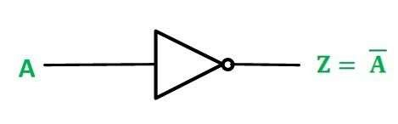

o Example: A system that opens a valve when the pressure is low (input 0) and closes it when the pressure is high (input 1).

1. NAND Gate

o The NAND gate is the complement of the AND gate. It produces an output of 0 only when all its inputs are 1. o Truth Table:

Input A Input B Output (A NAND B)

* 1. 0 1
  2. 1 1
  3. 0 1
  4. 1 0

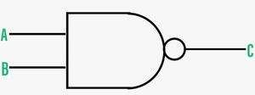

1. Symbol of NAND Gate

o

o Example: Used in digital locks, where the lock disengages only when both conditions are satisfied (but inverted).

1. NOR Gate

o The NOR gate is the complement of the OR gate. It produces an output of 1 only if all its inputs are 0. o Truth Table:

Input A Input B Output (A NOR B)

* 1. 0 1 0 1 0
  2. 0 0 1 1 0

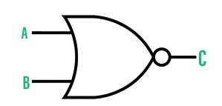

1. Symbol of the NOR Gate

* o
* Example: In alarm systems, a NOR gate can be used to trigger an alert if neither of two safety conditions is met.